COMSATS University Islamabad,

Attock Campus

**Department of Computer Science**



Submitted by:

**Muhammad Hamza (FA21-BCS-058)**

Submitted to:

**DR. Bilal Bukhari**

**Subject:** Compiler Construction

**Lab Terminal**

**Q4 :- Explain the input and output of your mini compiler, screenshots.**

**INPUT:-**

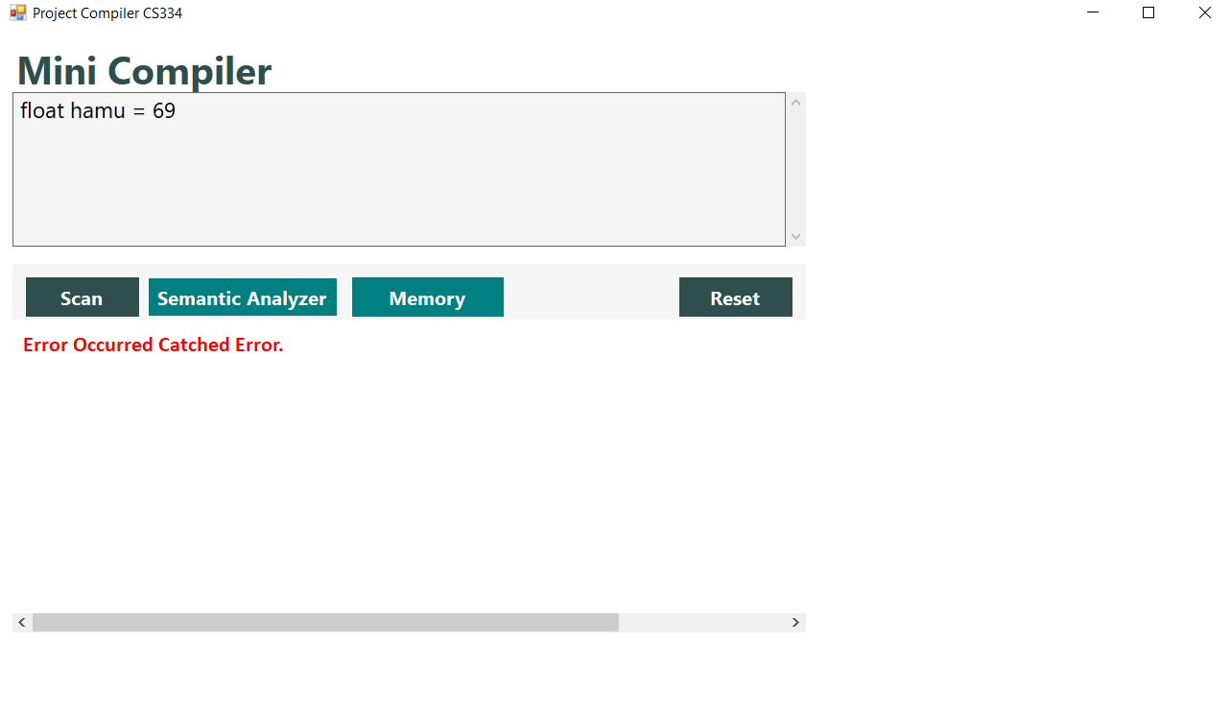

**OUTPUT:-**

